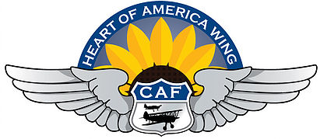

Welcome to the first edition of an old favorite, the Heart of America Wing’s re-vamped newsletter! We hope you will provide feedback to make this better / a success, and provide any stories you’d like to share with the Wing. Don’t be shy, there are no stupid comments or ideas (but Brian von Bevern does have some silly ones from time to time)! Feel free to send in your suggestions, but seriously, if they are not cool, don’t expect any trophies. It’s like talking on the radios… if you don’t sound cool, then don’t bother. (Just Kidding!!)
Please send any ideas or stories to anitamack130@gmail.com.
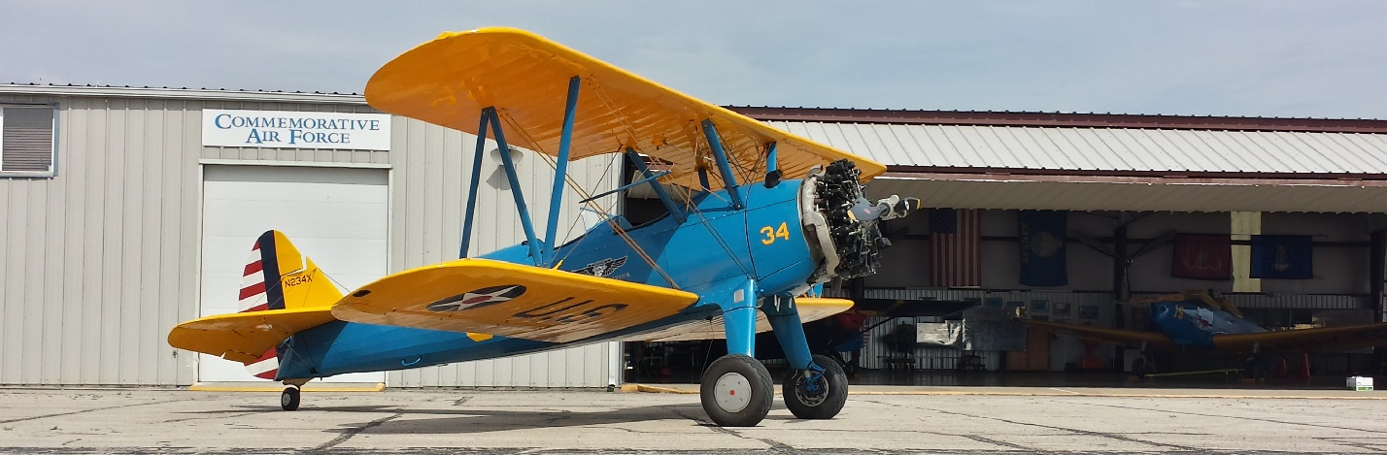

Restoration Update:
Our friends at Airbase Georgia (formerly the Dixie Wing of the CAF) are gluing the last skins on the right wing for our PT-19, undergoing restoration. Paul Brunks, team leader, is the guy in the hat; I can't remember the other two. Photos taken and provided by Charles Burcher.
Brian Von Bevern

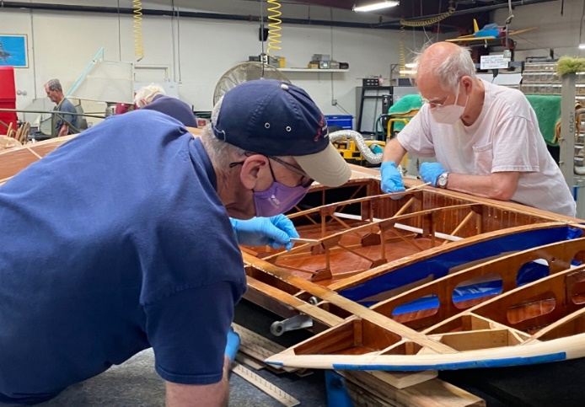
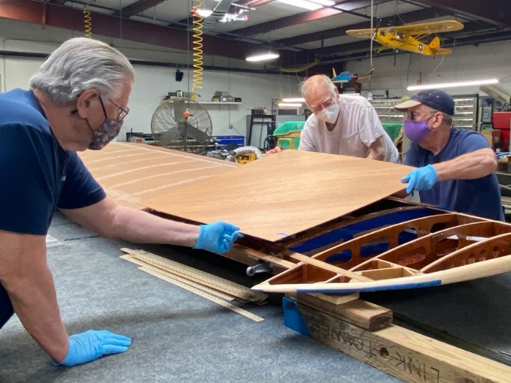
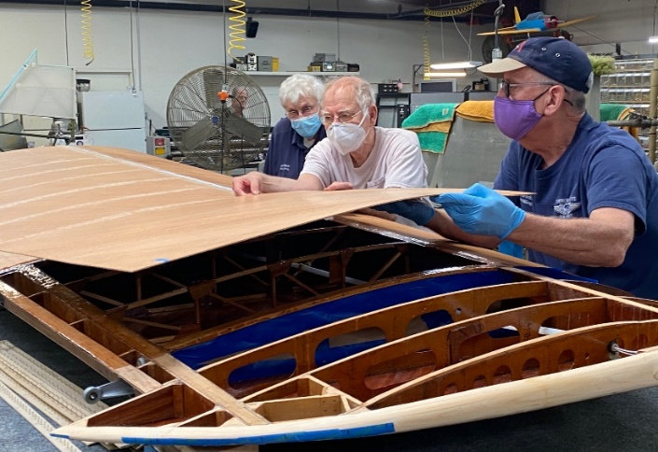

Events This Month During World War II:
9 Apr 1942: The Battle of Bataan ends with a Japanese victory and The Bataan Death March begins.
18 Apr 1942: The Doolittle Raid on is launched against Tokyo.
21 Apr 1942: Edward “Butch” O’Hare becomes first US Navy recipient of the Medal of Honor. Lt O’Hare, a St Louis native and son of the lawyer who helped convict Al Capone, became the Navy’s first ace on 20 Feb 1942 when he shot down five Japanese Betty bombers attacking his carrier, the Lexington. These actions earned him the Medal of Honor. Lt O’Hare was lost in action on the night of 26 Nov 1943 leading the first night mission launched from an aircraft carrier. In 1949, the Chicago airport would be renamed O’Hare International Airport in his honor. A F4F Wildcat similar to the kind he flew is displayed in Terminal 2.
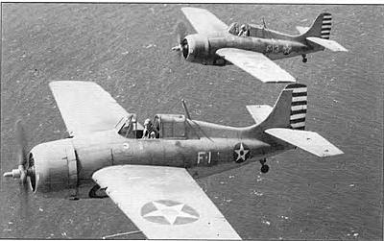
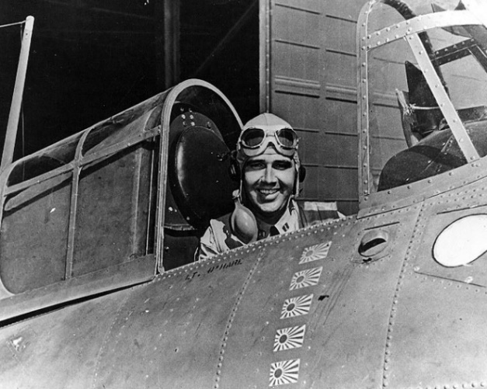
1 Apr 1943: SIGSALY, the secure phone system for calls between Pres Franklin Roosevelt and Prime Minister Winston Churchill, becomes operational. Developed by Bell Labs of AT&T, it encrypted calls. Terminals were set up in the Pentagon in Washington D.C. and the basement of the Selfridges department store in London.
15 Apr 1943: The US Army starts using V-Mail to get letters to and from servicemen. It photographed the letters onto microfilm for shipment and would be enlarged at its destination. What would normally take 37 mail bags carrying 150,000 letters weighing 2,575 lbs was replaced by a single mail bag weighing 45 lbs. It also prevented possible espionage attempts because communication techniques would not be reproduced in the photocopy. This technique was invented in the 1930s by the Eastman Kodak Company for Imperial Airways and Pan-Am Airways to reduce the weight and bulk of air mail.
18 Apr 1943: Admiral Isoroku Yamamoto, Commander In Chief of the Japanese Navy and planner of the attack on Pearl Harbor, was killed when the plane he was flying in was shot down by a US Navy P-38 over Bougainville Island. Coincidentally, it was the one year anniversary of the Doolittle Raid. The Japanese coded message had been received and decoded by Naval Intelligence on 14 Apr, and planning started. The mission required flying more than 400 miles in radio silence, dead reckoning over the ocean, and flying at sea level to avoid radar detection. The P-38s would only have 5-10 minutes of loiter time over the anticipated target area which based 75 Zeros, and the mission was given 1000-1 odds of success. The US pilots returned and started a celebration that would not be damped even by a bombing attack on the base that evening. A reporter in a foxhole wrote, “This is the nosiest raid I know, not so much from the bombs and ack-ack but from officers who started singing early in the evening and are still out in the moonlight singing like a bunch of high school kids after a ball game”.
“Death by P-38: When America Killed Japan’s Top Admiral”
https://www.historynet.com/death-by-p-38.htm

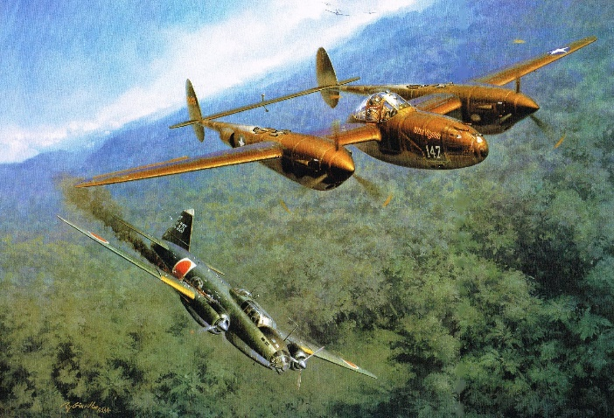
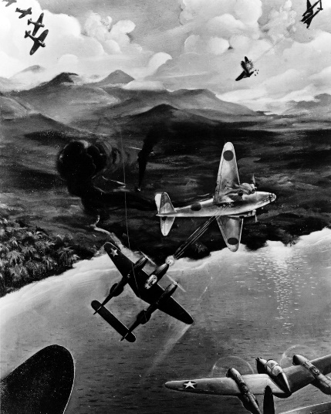

30 Apr 1943: The body of “Major Martin” was released from the submarine HMS Seraph as part of Operation Mincemeat. “Major Martin” was really Glyndwr Michael, a vagrant who died and was dressed as a Royal Marine. Fake military papers were place on his body that disclosed an Allied invasion of Greece and Sardinia. The body was picked up and the papers sent to German military intelligence. German messages decoded by the Allies proved that the Germans believed the deception and that German reinforcements were sent to Greece and Sardinia leaving the real location of the invasion, Sicily, without reinforcements. Sicily was liberated faster with fewer losses than planned.
Operation Mincemeat
https://en.wikipedia.org/wiki/Operation_Mincemeat

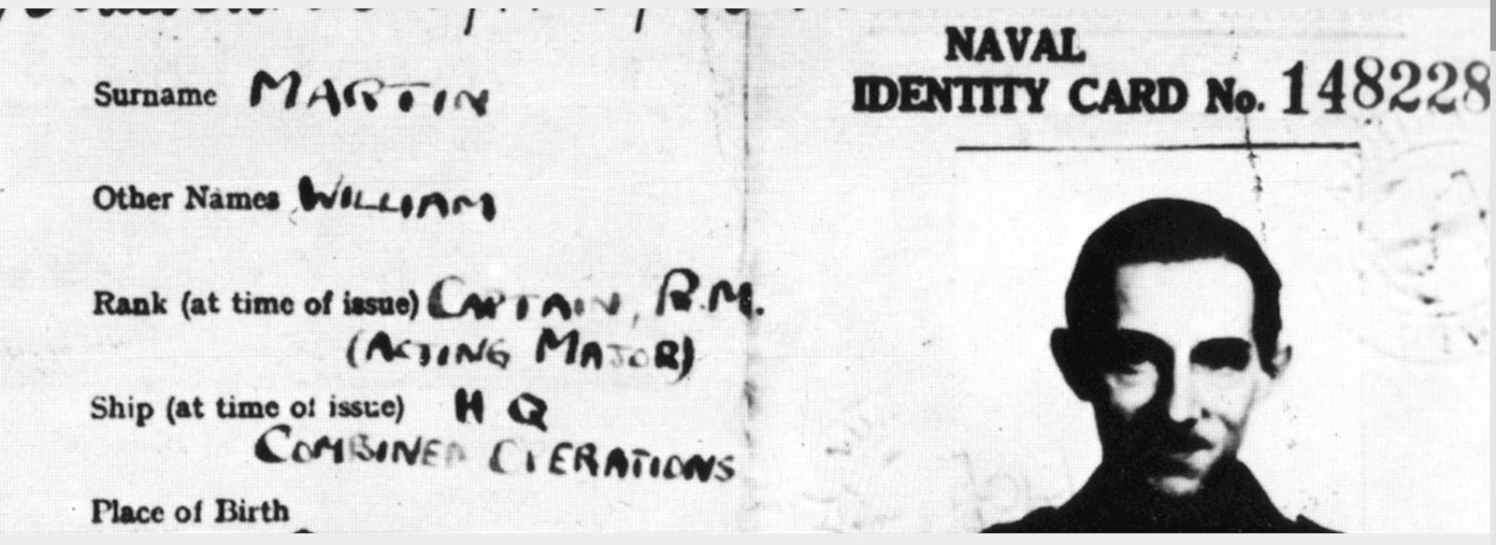

18 Apr 1944 – The Allies set a new single day record by dropping 4,000+ tons of bombs on Germany.

1 Apr 1945 – The first day of the Battle of Okinawa, 50,000 American troops landed on the beaches, which was the largest amphibious assault in the Pacific Theater. The battle lasted 98 days and proved to be one of the bloodiest. Military casualties between both American and Japanese forces are estimated to be about 160,000 but the greater tragedy was the loss of about half of the 300,000 Okinawan locals, including some who killed themselves and their families out of fear based on propaganda of the “barbarian” American soldiers.

12 Apr 1945 – President Franklin D. Roosevelt had a stroke and died, Harry S. Truman was sworn in as President.

15 Apr 1945 – First flight of the XP-82 Twin Mustang.

16 Apr 1945 – Battle of Berlin begins.

17 Apr 1945 – The B-26 Marauder “Flak Bait” completed its 200th bombing mission.

30 Apr 1945 – Adolf Hitler aged 56, and his wife of 2 days, Eva Braun aged 33, committed suicide in the Fuhrerbunker.

Maintenance Officer Update:
PT-19: The Atlanta Airbase is still making progress on the PT-19, although COVID -19 has slowed the pace quite a bit. Two members working two days a week is about all that they can do. The right wing is almost complete as far as woodworking goes. It still needs to be covered in fabric and painted. Work will be starting on the left wing shortly. At first glance, they thought it would not need as much work but are now thinking that they will be making all new ribs as they did for the right wing. The learning curve should not be as steep though. The center section is still on our hangar. I am researching some other options to get it worked over. The fuselage needs some welding and then painted. It is in Gardner at the main shop, but we have run into some snags from the city about doing welding in the shop. I am looking into some other options for that also.
PT-13: The Stearman is in the middle of its annual inspection. Hope to be done by the third week of April. So far, nothing major has shown up. We still have compression checks and a few other things to do. We will be replacing the tailwheel boot, because the one that in there now has deteriorated and is very brittle. Thanks to Mike Batliner, Brian Von Bevern, Jerry Sladish, and John Wittenborn for their help.
We are out of oil in our 55 gallon drum. I am researching the best place to get oil. It is very expensive, approximately $1600 plus delivery. We might change to a multi-grade oil and buy it buy the case for awhile until we can start bringing in some income. It is about $6 cheaper per gallon by the barrel, so when I find the best deal I can get, we will go back to a barrel of oil.
Steve Zimmerman
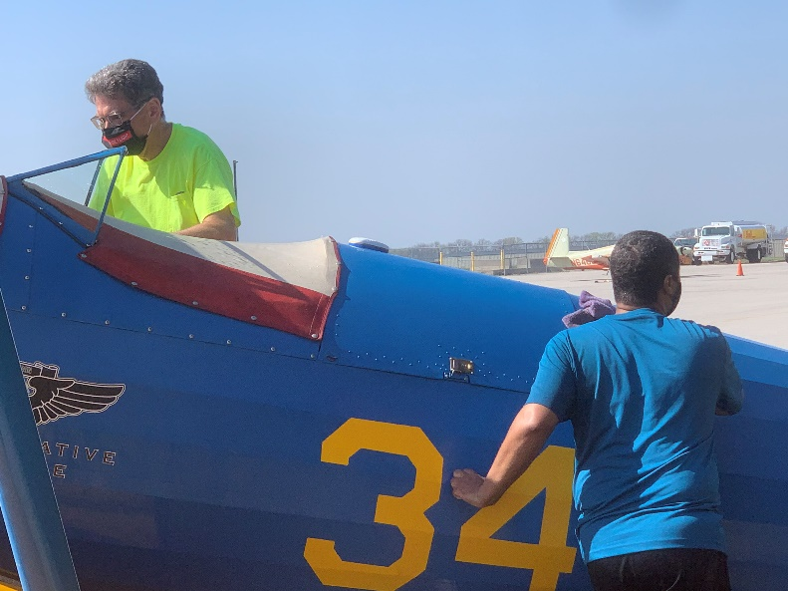
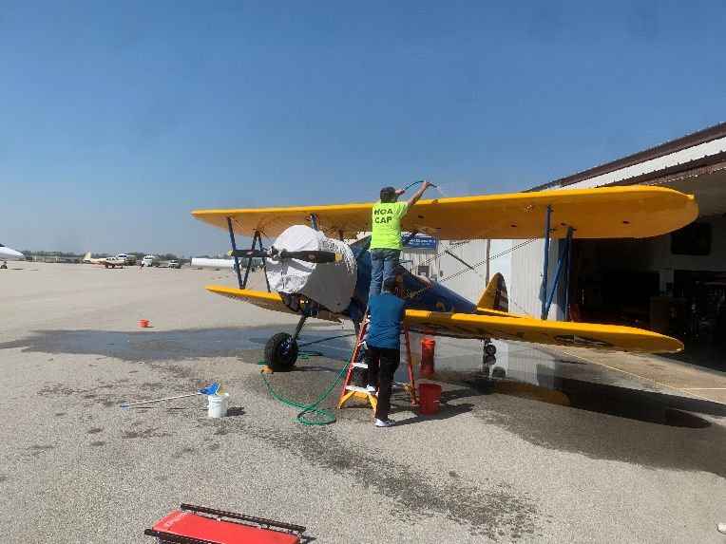

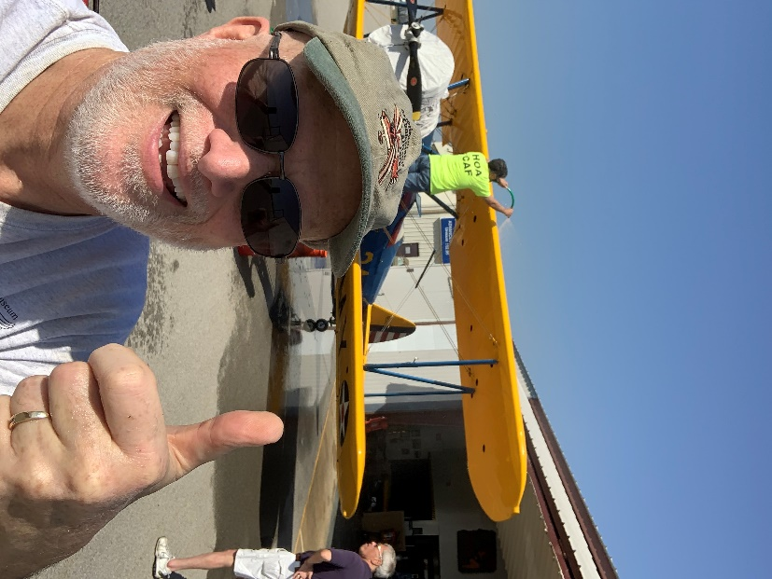
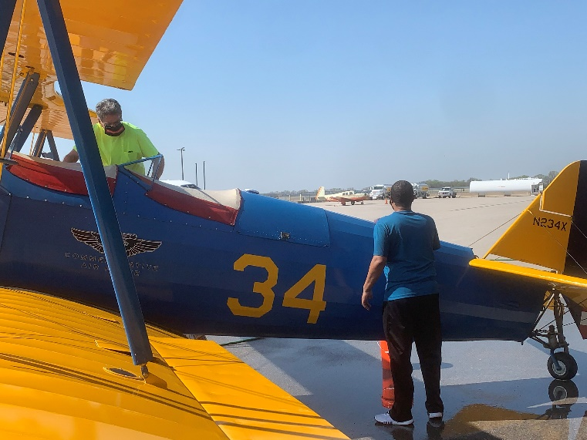

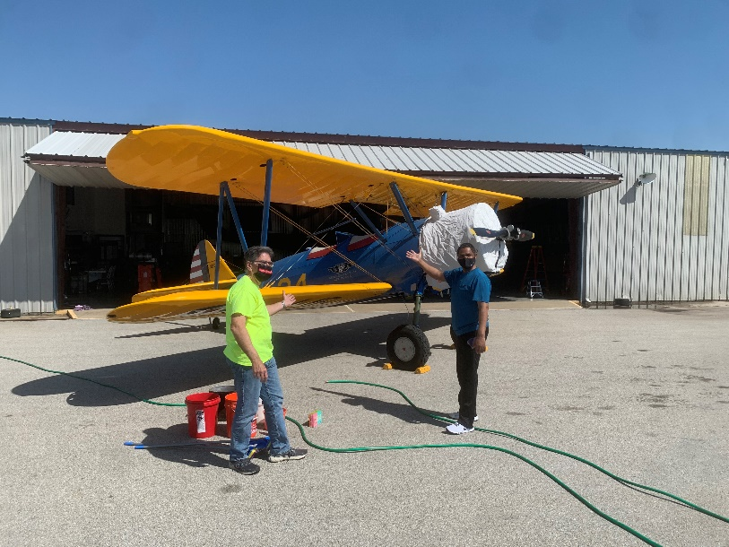
11 Apr: the Stearman got a ''bath" as part of its FAA-required annual inspection. After putting on the cockpit and engine covers to keep the water away from where it shouldn't be, Wing members washed away a year's worth of dirt, oil, and grease. Helping with the hose and suds were Jerry Sladish, Kim Crockett, Tom McChesney, John Wittenborn, and Brian Von Bevern. We're hoping to have the inspection done by next week, so we can start the flying season.
Brian Von Bevern
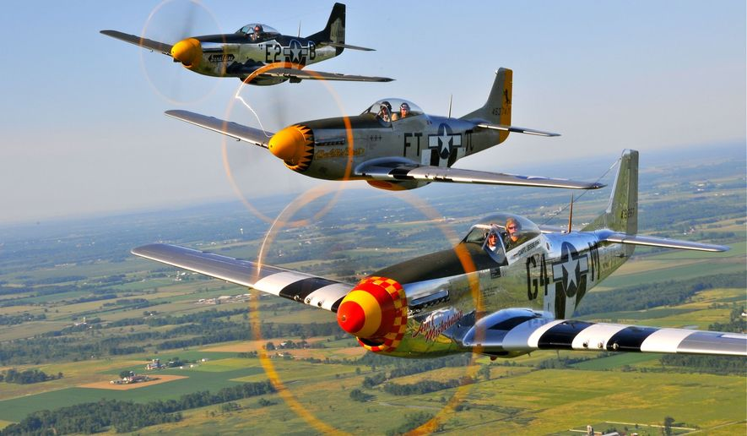
Upcoming Events:
Airshows/Events (Tentative):
8 May: Fly-In, Garnett KS (K68)
29-31 May: HOA Wing will fly to Spirit of St Louis Airport (KSUS) for Wings Over St Louis over Memorial Day weekend. The Missouri Wing will have the ramp set up with the B-25, TBM Avenger, and L-3 to name a few aircraft. Both Wings will give ride flights and encourage members of the public to get up close to warbirds and learn more about the CAF mission.
25-27 Jun: Thunder Over The Heartland, Forbes Field Topeka (FOE)
3-5 Jul: Kansas City Air Show, New Century Air Center (IXD)
17 Jul: Amelia Earhart Festival, Atcheson (K59)
30 Aug-8 Sep: Fly-In with “Made In The Shade” B-25 with Arizona Air Base, Springfield MO (SGF)
16-19 Sep: Great Bend Air Show, Great Bend KS (GBD)

Open Hangar Days:
5 Jun – “Pet Palooza”
7 Aug – Vintage Japanese Motorcycle Club

16 Oct - Hangar Dance with “The Moonlight Serenaders”

